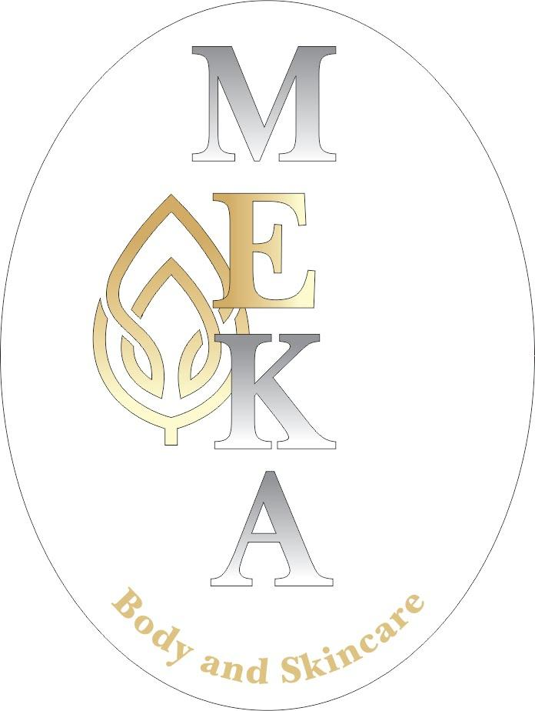
Airbrush Tanning Before/After Care

-- Take a shower, shave and lightly exfoliate with a non moisturizing scrub/bar or washcloth before tanning session
-- If you condition your hair, do so before you scrub.
-- After the shower, do not apply any deodorant, lotions, oils or perfumed products as it will create a barrier for the tan
-- Arrive to session with no make-up (lipstick/balm ok), jewelry removed, hair pulled back, deodorant & lotion taken off
-- The tanning solution contains a bronzer; so wear dark colored, loose clothing after session. If you have very light colored or leather seats, we recommend wearing longer pants or bringing a small towel to prevent the bronzer from possibly rubbing onto seats.
-- Sandals or flip-flops are best to wear out {unless raining, then wear covered shoes}
-- Please have your tanning attire on underneath your clothes & ready to go
-- Most women airbrush tan topless & in a thong OR a strapless bra & underwear. If you are currently breast feeding, adhesive nursing pads or a strapless bra must be worn
-- Men may wear boxers, briefs or swim wear.
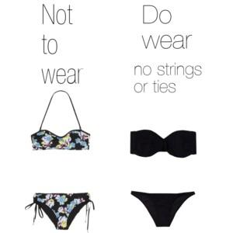
-- Results are best achieved if you wait to bathe 8-12 hours after your tanning session, preferably keep your tan on overnight
-- Do not shave within 24 hours of your initial tan application
-- Do not exfoliate the skin for 7 days as this will cause your tan to fade more quickly
-- Moisturize daily after the first shower following your tanning session to make your tan last longer & fade evenly. The tan will last 7-10 days depending on: exfoliation prior to session, hydration and individual body chemistry.
-- If your tan has started to break down, please exfoliate thoroughly before your next session. Use lathered exfoliating gloves to take off the leftover tan in a circular motion.
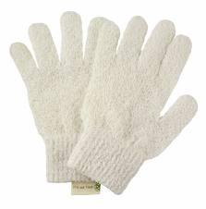
RAINY DAY SUGGESTIONS:
-- We do not recommend an umbrella; bring a covered parka with sleeves and hoodie to fully cover your airbrush.
-- Be covered head to toe! Please wear long loose dark pants, a long sleeve loose covered top, covered shoes and hoodie preferably.

